OneDrive Instructions

1. Go to OneDrive.com.
2. Follow prompts: enter email address you would like to use for your account and create a password.
3. Click on one of the OneDrive links in my weekly emails, or use this link to get into the Third Street Mondays folder:
https://onedrive.live.com/?id=A63216B2B620C6B7%21531&cid=A63216B2B620C6B7
4. The Third Street Mondays folder will open. From here, you can access:
  - Our weekly calendar to sign up to share work
  - Our writing resources folder
  - Our Work for Sharing folder (to download members’ pieces or upload your own work for sharing).
Note: If you are concerned about your files accidentally being modified, upload your piece as a PDF file.
5. To upload work:
- Go into the Work for Sharing folder.
- Click on “Upload” and choose “Files” from dropdown menu.

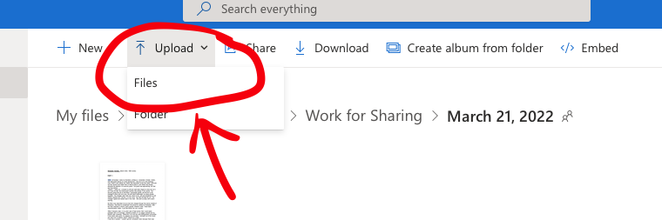

- Choose the document saved on your device you wish to upload to the folder.
6. To download work:
- Move your cursor over the upper righthand corner of the document you wish to download. Click on the circle that appears.
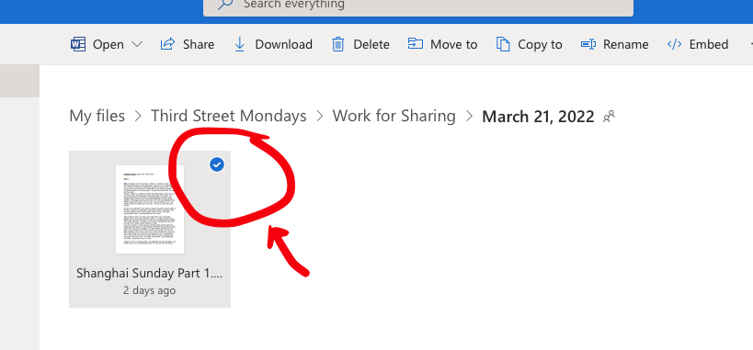
- Click on “download.” The file will be saved in your downloads folder.

Note: If you have signed up to have your work critiqued, please upload your piece by Friday so members may have time to review. If you are sharing your work, also please bring 4-5 print copies for those who can’t print or for newcomers.

